ROSSMOYNE SENIOR HIGH SCHOOL


Yr11/12 Semester Two Examination, 2012

Question/Answer Booklet

MATHEMATICS 2C/2D

Section Two:

Calculator-assumed

Your name

Teacher’s name

Time allowed for this section
Reading time before commencing work: ten minutes
Working time for this section: one hundred minutes

Materials required/recommended for this section

To be provided by the supervisor
This Question/Answer Booklet
Formula Sheet (retained from Section One)

To be provided by the candidate
Standard items: pens, pencils, pencil sharpener, eraser, correction fluid/tape, ruler, highlighters

Special items: drawing instruments, templates, notes on two unfolded sheets of A4 paper, and up to three calculators satisfying the conditions set by the Curriculum Council for this examination.

Important note to candidates

No other items may be used in this section of the examination. It is your responsibility to ensure that you do not have any unauthorised notes or other items of a non-personal nature in the examination room. If you have any unauthorised material with you, hand it to the supervisor before reading any further.

Structure of this paper

Section | Number of questions available | Number of questions to be answered | Working time (minutes) | Marks available | Percentage of exam
Section One:  Calculator-free | 7 | 7 | 50 | 50 | 33
Section Two:  Calculator-assumed | 12 | 12 | 100 | 100 | 67
 |  |  | Total | 150 | 100

Instructions to candidates

- The rules for the conduct of Western Australian external examinations are detailed in the Year 12 Information Handbook 2012. Sitting this examination implies that you agree to abide by these rules.

- Write your answers in the spaces provided in this Question/Answer Booklet. Spare pages are included at the end of this booklet. They can be used for planning your responses and/or as additional space if required to continue an answer.
- Planning: If you use the spare pages for planning, indicate this clearly at the top of the page.
- Continuing an answer: If you need to use the space to continue an answer, indicate in the original answer space where the answer is continued, i.e. give the page number. Fill in the number of the question(s) that you are continuing to answer at the top of the page.

- Show all your working clearly. Your working should be in sufficient detail to allow your answers to be checked readily and for marks to be awarded for reasoning. Incorrect answers given without supporting reasoning cannot be allocated any marks. For any question or part question worth more than two marks, valid working or justification is required to receive full marks. If you repeat an answer to any question, ensure that you cancel the answer you do not wish to have marked.

- It is recommended that you do not use pencil, except in diagrams.

Section Two: Calculator-assumed (100 Marks)
This section has twelve (12) questions. Answer all questions. Write your answers in the spaces provided.

Working time for this section is 100 minutes.

Question 8 (7 marks)
(a) Write down a recursive rule for the arithmetic sequence 35, 29, 23, 17, ... (2 marks)

(b) A different sequence is defined by 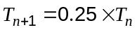, 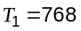.

(i) Write down the first three terms of this sequence. (2 marks)

(ii) Write down 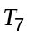. (1 mark)

(iii) Calculate 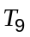, rounded to 3 significant figures. (2 marks)

Question 9 (7 marks)
The cost per unit of gas used by residential customers in a city depends upon their average daily consumption, as shown in the table below.

Residential Customers | Prices including GST
Supply charge | 18.54 cents per day
The first 12 units used on average per day | 12.79 cents per unit
Over 12 units used on average per day | 11.54 cents per unit

(a) A consumer used an average of 9 units of gas per day over a period of 91 days.

(i) Calculate the supply charge for a period of 91 days. (1 mark)

(ii) Calculate the cost of using 9 units per day for 91 days. (1 mark)

(iii) Calculate the total of the supply charge and gas cost for this consumer. (1 mark)

(b) Another consumer used a total of 900 units of gas over a period of 60 days.

(i) How many units did they use on average per day? (1 mark)

(ii) Calculate the total of the supply charge and gas cost for this consumer. (3 marks)

Question 10 (8 marks)
In a recent survey of Australian households (the universal set U), it was noted that 40% own dogs (set D), 27% own cats (set C) and 48% own neither.

(a) Express this information using a Venn diagram, completing any missing entries. (3 marks)

(b) What percentage of households owned both dogs and cats? (1 mark)

(c) Describe the pet ownership of members of the set 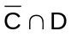. (1 mark)

(d) If a household is chosen at random, determine

(i) 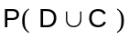 (1 mark)

(ii) the probability that they own a dog given that they own a cat. (2 marks)

Question 11 (4 marks)
On the axes below, draw the graph of 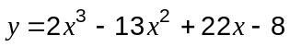, labelling all axes intercepts.
(4 marks)

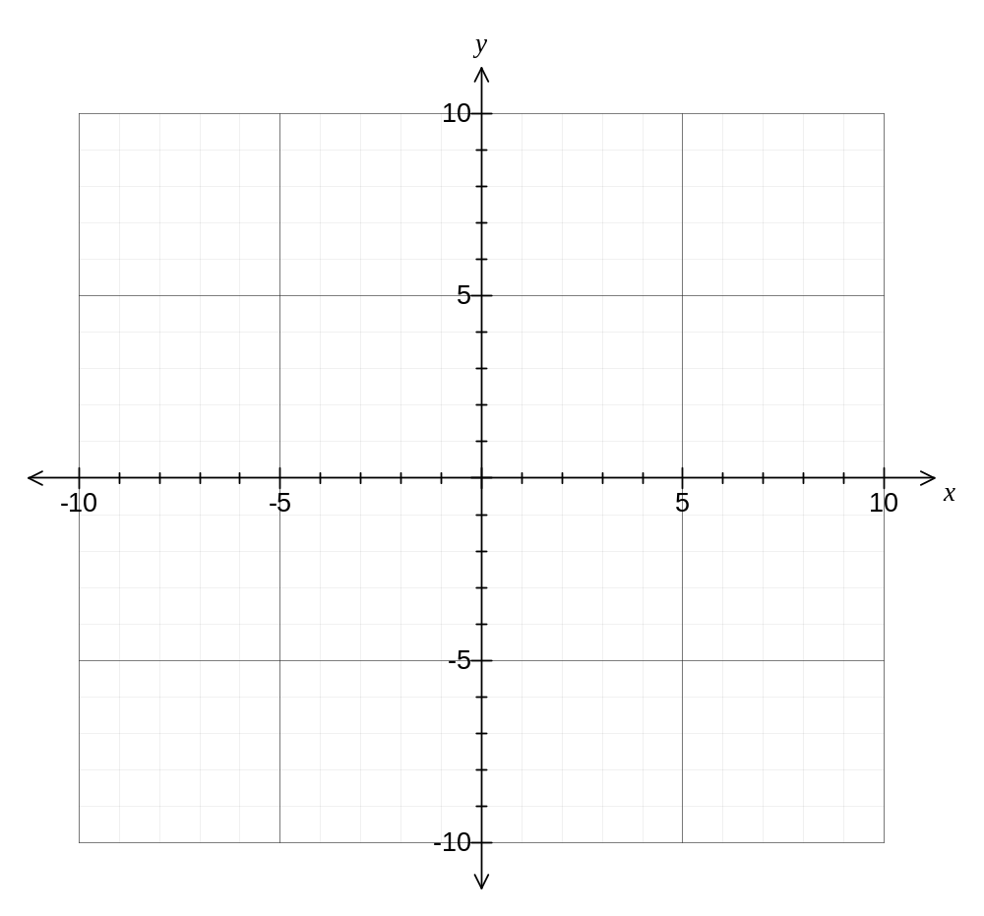

Question 12 (9 marks)
(a) A straight ladder, 3.5 m long, stands on level ground and leans against a vertical wall so that it reaches 2.8 m up the wall.

(i) Sketch a diagram of the ground, wall and ladder, showing all given measurements.
(1 mark)

(ii) Calculate the angle that the ladder makes with the ground. (2 marks)

(b) The two ends of a length of rope are tied together to make a loop of length 45 m. The loop is then stretched out tightly on level ground to form a triangle.

(i) Calculate the area of this triangle, if it has three equal sides. (3 marks)

(ii) Calculate the size of the smallest angle in the triangle, if two of the sides are both 20 m long. (3 marks)

Question 13 (11 marks)
Each number on the network below represents the distance, in kilometres, between adjacent vertices.

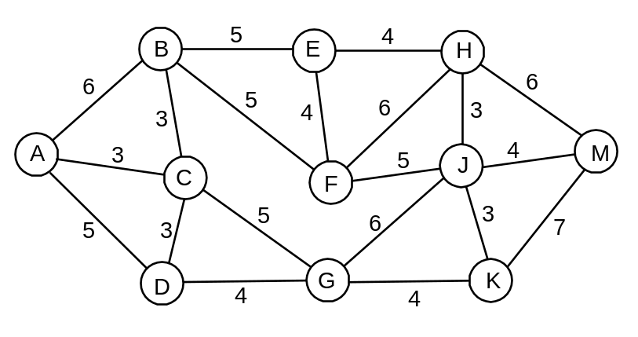

(a) Find the length of the minimum spanning tree of the network above, clearly indicating the tree on the diagram. (3 marks)

(b) The network below is a copy of the one above. Determine the length of the shortest path from A to M and list the vertices passed through. To obtain full marks, numbers must be added to the diagram to show that a systematic method has been used. (4 marks)

(c) The following network shows the maximum number of daily flights between airports A to F in an easterly direction.

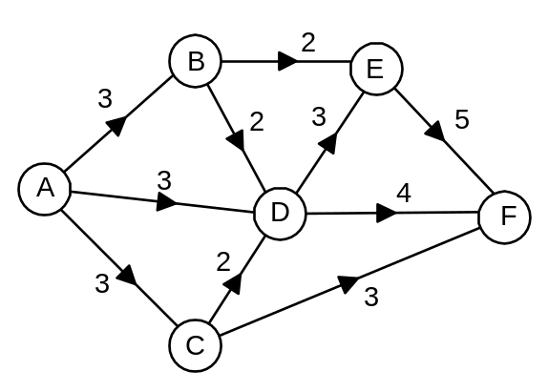

If each flight can carry 300 passengers, what is the maximum number of passengers that can be carried from A to F in a day? Systematic working must be shown to be awarded full marks. (4 marks)
Question 14 (11 marks)
A newspaper contained an advertisement for a laptop computer with a cash price of $999.

(a) The computer could also be bought on credit over three years by weekly payments of $11.92, subject to approval.

(i) Assuming there are 52 weeks per year, how much would the computer cost if bought on credit? (1 mark)

(ii) How much interest is paid using the credit terms? (Assume that the interest is the extra amount paid when buying the computer on credit instead of cash). (1 mark)

(iii) Calculate the simple interest rate that would generate the interest calculated in (ii) on the cash price over the credit period. (3 marks)

The same newspaper carried another advertisement from a lender offering unsecured loans for amounts up to $3000 at a rate of 15.9%pa with interest compounded monthly.

(b) How much interest would accumulate on a loan of $999 over three years, if no repayments were made? (3 marks)

(c) The recursive formula 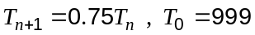 can be used to calculate the value of the laptop computer after years.

(i) What annual rate of depreciation does this formula use? (1 mark)

(ii) Calculate the value of the computer after five years, rounded to the nearest $10.
(2 marks)

Question 15 (12 marks)
An electronics student built a circuit and display to generate random numbers from 0 to 99. The circuit designer claimed that all numbers had an equal chance of being chosen.

The first seven numbers generated by the circuit were 12, 5, 41, 64, 37, 2 and 23.

(a) For these seven numbers,

(i) write down the median (1 mark)

(ii) write down the range (1 mark)

(iii) explain why it does not make sense to calculate the mode. (1 mark)

To thoroughly test the circuit, 1000 numbers were generated and summarised in the table below.

Number | 0-9 | 10-19 | 20-29 | 30-39 | 40-49 | 50-59 | 60-69 | 70-79 | 80-89 | 90-99
Frequency | 167 | 172 | 151 | 121 | 97 | 74 | 85 | 51 | 47 | 35

(b) For these 1000 numbers,

(i) calculate the mean (2 marks)

(ii) calculate the standard deviation (1 mark)

(iii) write down the modal group. (1 mark)

(c) Construct a frequency histogram for the 1000 numbers on the axes below. (3 marks)

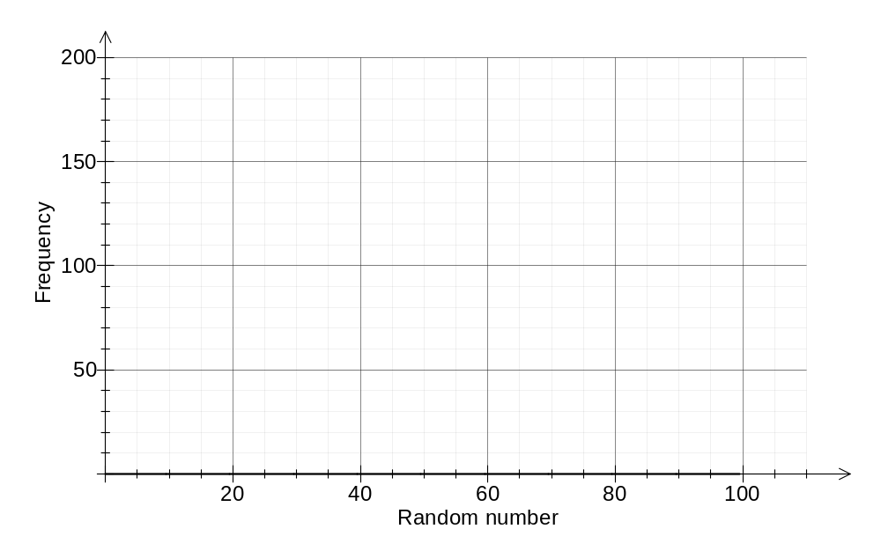

(d) Use the above information to state whether the circuit designer's claim, that all numbers have an equal chance of being chosen, is justified. Explain your answer. (2 marks)

Question 16 (7 marks)
A student wants to watch two different movies over the weekend, one on Saturday and one on Sunday. They have four movies to choose from, listed in the table below:

Movie | Director | Year Released | Rating
Avatar | James Cameron | 2009 | PG
Chinatown | Roman Polanski | 1974 | M
Tess | Roman Polanski | 1979 | PG
Up | Pete Docter | 1979 | PG

(a) Draw a tree diagram to show all the different orders they could watch two of these movies over the weekend. (2 marks)

(b) Given that all orders are equally likely, what is the probability that the student watches

(i) 'Avatar' on Saturday and 'Tess' on Sunday? (1 mark)

(ii) only movies directed by Roman Polanski? (1 mark)

(iii) at least one movie released in the 1970's? (1 mark)

(iv) the movie 'Up', given that both movies they watched were rated PG? (2 marks)

Question 17 (8 marks)
The graph below shows the average weekday cyclist traffic flow on Bridge Road from 1993 to 2002. Data was not available for 1997 and 2000.
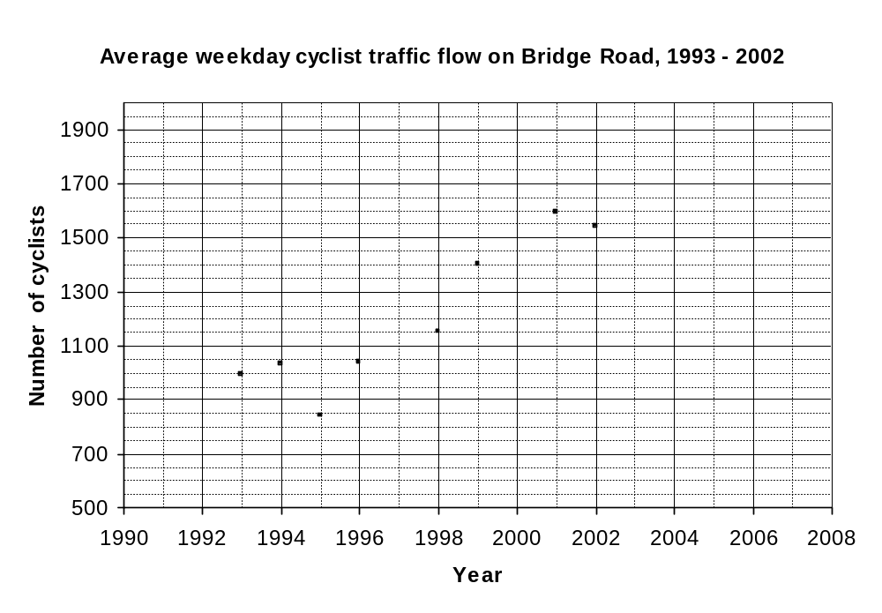
(a) What was the average weekday cyclist traffic flow in 1994? (1 mark)

(b) The average weekday cyclist traffic flow in 1997 was 1135. Add this point to the graph.
(1 mark)

(c) Draw a trend line on the graph. (2 marks)

(d) Use your trend line to estimate the average weekday cyclist traffic flow in:

(i) 2000 (1 mark)

(ii) 2004 (1 mark)

(e) Comment, with reasons, on the reliability of each of your predictions in (d). (2 marks)

Question 18 (6 marks)
A motoring club is planning an event and wants to know what its members would like. They plan to ask 80 members, chosen at random, from the total membership of 685 people.

(a) An extract from a table of three-digit random numbers is shown below:

940 517 279 109 794 984 096 085 781 109

(i) Choose one of the numbers from the list and explain how the club could use it to select one of their members. (2 marks)

(ii) How many numbers in the above list could be used to select a sample? Explain your answer. (2 marks)

(b) One of the questions that the club plans to ask is the age of the member. They know that the youngest is 17 and that the oldest member is 63. Two possible data summary tables are shown below:

Design A |  |  | Design B
Age | Frequency |  | Age | Frequency
15 - 25 |  |  | 10 - 19
25 - 35 |  |  | 20 - 59
35 - 45 |  |  | 60 - 69
45 - 55
55 - 65

(i) State one disadvantage of using Design A. (1 mark)

(ii) State one disadvantage of using Design B. (1 mark)

Question 19 (10 marks)
(a) and are related by the formula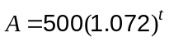.

(i) Evaluate when 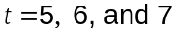. (2 marks)

(ii) Estimate the solution to 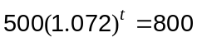 if must be a whole number. (1 mark)

(b) The graph of 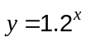 is drawn below.
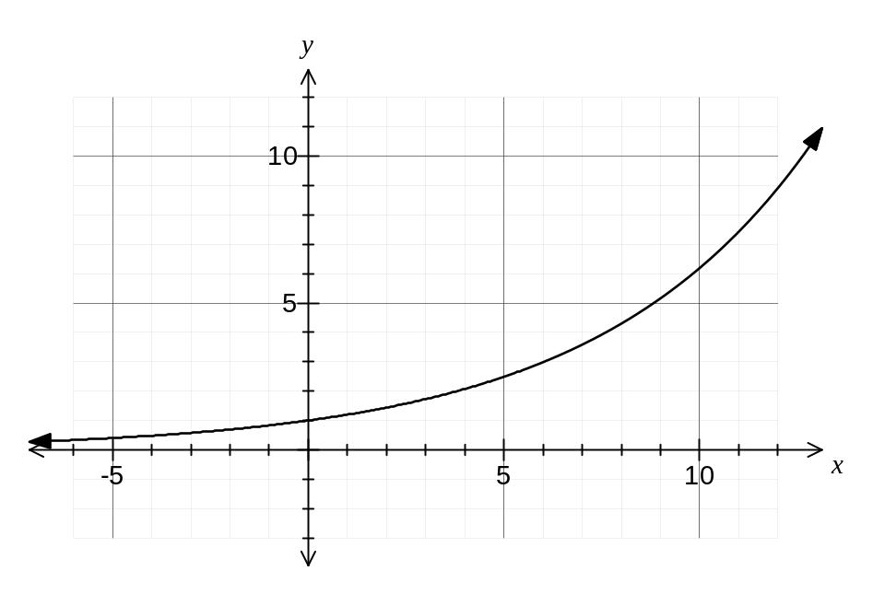
(i) Show use of the graph to solve the equation 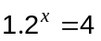.
(2 marks)

(ii) Add the graph of 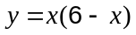 to the axes above. (3 marks)

(iii) Explain how to use the two graphs above to solve the equation 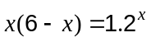, and state how many solutions there are. There are no marks for solving the equation.
(2 marks)

Additional working space

Question number: _________

Additional working space

Question number: _________

This examination paper may be freely copied, or communicated on an intranet, for non-commercial purposes within educational institutes that have purchased the paper from WA Examination Papers provided that WA Examination Papers is acknowledged as the copyright owner. Teachers within purchasing schools may change the paper provided that WA Examination Paper's moral rights are not infringed.

Copying or communication for any other purposes can only be done within the terms of the Copyright Act or with prior written permission of WA Examination papers.

Published by WA Examination Papers
PO Box 445 Claremont WA 6910

